Documentation of Customer Offer Engagement Report
Power BI Report Documentation
June 27, 2026

Table of Contents
1. Introduction
2. Data Model
3. Measures
4. Calculated Columns
5. Power Query
6. Visualizations
7. Conclusion and Recommendations

Introduction
This document provides comprehensive documentation for the Customer Offer Engagement Power BI report. The report offers insights into customer conversion, offer performance, and customer behavior.

Data Model
Tables:
- events
- customers
- offers
- offers_channels

Relationships:
- customers[customer_id] → events[customer_id] (One to Many)
- offers[offer_id] → events[value.offer_id] (One to Many)
- offers_channels[offer_id] → events[value.offer_id] (Many to Many)

Measures

- Offer Completed Count = CALCULATE(COUNTROWS(events),events[event] = "offer completed")

- Offer Viewed Count = CALCULATE(COUNTROWS(events),events[event] = "offer viewed")

- Offer Received Count = CALCULATE(COUNTROWS(events),events[event] = "offer received")

- Redemption rate = DIVIDE([Offer Completed Count],[Offer Received Count],0)

- Transaction Count = CALCULATE(COUNTROWS(events),events[event] = "transaction")

Calculated Columns

- Customer Segment
Customer Segment =
VAR CompletedCount =
CALCULATE(
COUNTROWS(events),
FILTER(
events,
events[customer_id] = customers[customer_id]
&& events[event] = "offer completed"
)
)
RETURN
IF(
CompletedCount > 0,
"Completed Offer",
"Did Not Complete"
)

- Average Spend

Average Spend =
CALCULATE(
AVERAGE(events[value.amount]),
events[event] = "transaction"
)

- Week Number

Week Number =
INT(events[time] / 168) + 1

Power Query

- customers Table Transformation
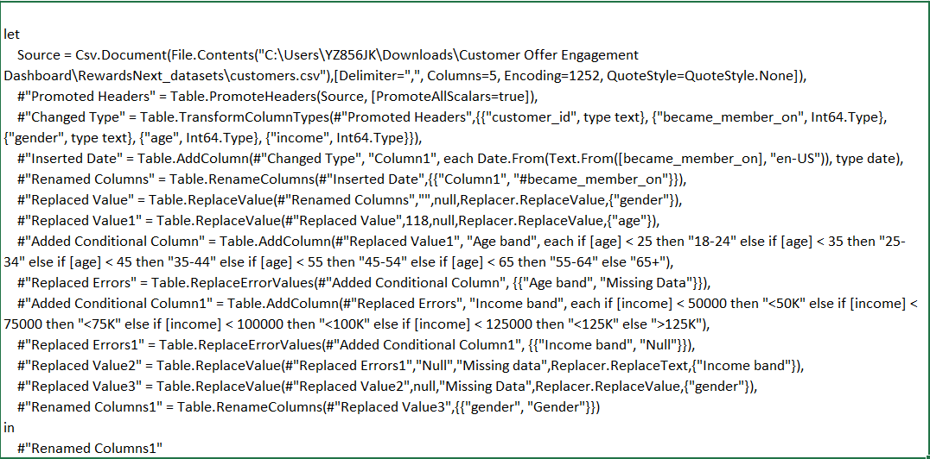

- offers Table Transformation
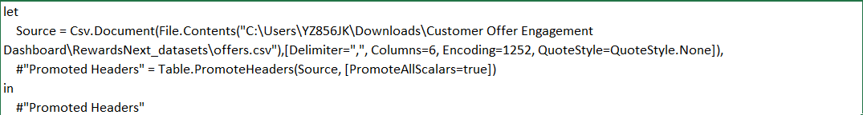

- offers_channels Table Transformation
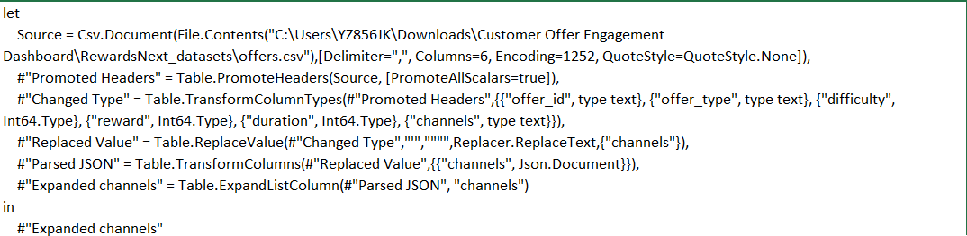
- events Table Transformation
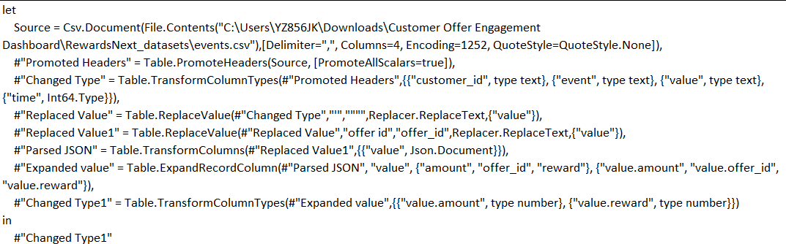

Visualizations
- Customer & Offer metrics with KPI cards
- Customer conversion funnel chart
- Demographic wise Redemption Rate
- Bar charts for offers performance
- Scatter plot of customer behavior

Recommendations for Further Development
- Data Source Management: Ensure that the file paths in the M code (e.g., Excel file paths) are updated if the data source locations change.
- Data Refreshes: Schedule regular data refreshes and monitor them to ensure data integrity.
- Measure Optimization: Review DAX measures periodically for performance optimization, especially those using time intelligence functions.
- Version Control: Implement version control for the Power BI report to track changes over time.
- Documentation Updates: Keep this documentation updated with any changes to the data model, measures, or transformations.
- Training: Provide training sessions for the team to understand the intricacies of the DAX measures and M code used.
- Performance Monitoring: Use Power BI's performance analyzer to monitor and improve report performance.
- Security: Ensure that appropriate row-level security is implemented if the report is distributed to different user groups.
- Visualizations: Regularly review and update visualizations to align with business needs and to leverage new Power BI features.

